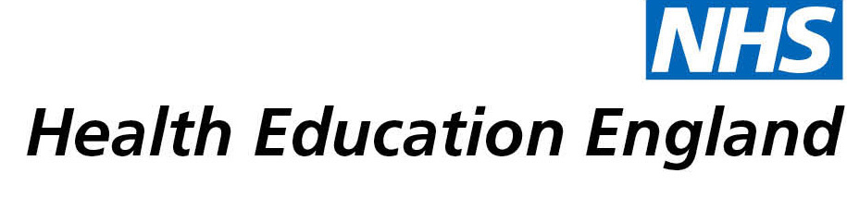

# Library and Knowledge Services case study

# *Lancashire Teaching Hospitals NHS Foundation Trust Library and Information Service: Supporting Emergency Department Pharmacists*

Date February 2021

## Reason for enquiry

The Emergency Department prescribing pharmacist contacted the Library for help sourcing an article to help inform patient care for an acutely unwell patient. The request was time sensitive.

## What the knowledge and library specialist did

The requested article was only available in German, which was not useful in this situation.

Library staff discussed alternative forms of support and agreed the following with the requester:

1. The Library Assistants sourced and provided the literature cited in the German article that was available in full text in English.
2. The Assistant Clinical Librarian carried out a literature search on the topic. A list of resources was provided along with copies of the full text wherever possible.

Both the articles and the literature search were provided in a timely manner on the same day.

# Impact of input from the library and knowledge service

The information provided by the Library contributed to more informed clinical decision making, as well as allowing the ED pharmacists to carry on seeing other patients that day.

## Immediate Impact

“Thank you so much for this, it’s really helpful and has meant we have both been able to carry on with seeing other patients today.”

“We are going to spend some time going through the articles this evening, but have been able to communicate some initial treatment plan options to the medical team based on the information you have sent.”

## Probable future Impact

“The patient was discharged from hospital with a plan and community follow up based on the scientific facts and opinions gathered from the articles the library provided. His care has been improved by the help we received from the library. Working clinically on the day we simply would not have had the time to do such a thorough literature search ourselves. Our team feel very lucky to have had the library team support us with this case – thankyou”

## Submission by:

Victoria Heald, Prescribing Pharmacist for ED and Acute Medicine

Lancashire Teaching Hospitals NHS Foundation Trust

## For further information on how you can get similar support contact your local NHS library and knowledge service.